

Fourth Grade Lakeside Learning Field Trip Application
Antelope Island State Park

SCHOOL INFORMATION
School Name
School Type (Public, Charter, Private, Homeschool, Other)
Is this a Title I School?
School District
School Address
School Phone

TEACHER INFORMATION
Name of Primary Teacher Contact
This is the teacher we will contact regarding scheduling details, etc. This teacher must be attending the field trip.
Primary Cell Phone Number
Primary Email Address
All Other Teachers/Classes Attending Same Field Trip
Name:
Email:
Name:
Email:
Name:
Email:
STUDENT INFORMATION
Expected Number of Students Attending Field Trip (Max. 75 students)
Over 75 students will require booking a second field trip day.
Do you have any students with special needs?
(Affecting their mobility or ability to see, hear, follow basic instructions, understand English, or otherwise participate safely in this outdoor field trip?)
If yes, please explain.

TRIP SCHEDULE
Spring 2026 season runs April 6-June 5
Preferred Field Trip Date
Second Choice
Third Choice
Program Schedule:
Start time (meet time) is 10:00am.
Program duration is 2.5 hours, ending at 12:30pm, not including time for lunch.
If your school needs a modified start or end time, or you have any other special scheduling needs, please explain here.
Lunch:
You are welcome to remain on the Island after our program to eat lunch. Please let us know if you have any questions about your lunch options.

Meeting Location:
FRIENDS staff will meet you in the parking lot just before you reach the Antelope Island Causeway Tollbooth (4739 W 1700 S, Syracuse, UT 84075) on the south/left side of the road.
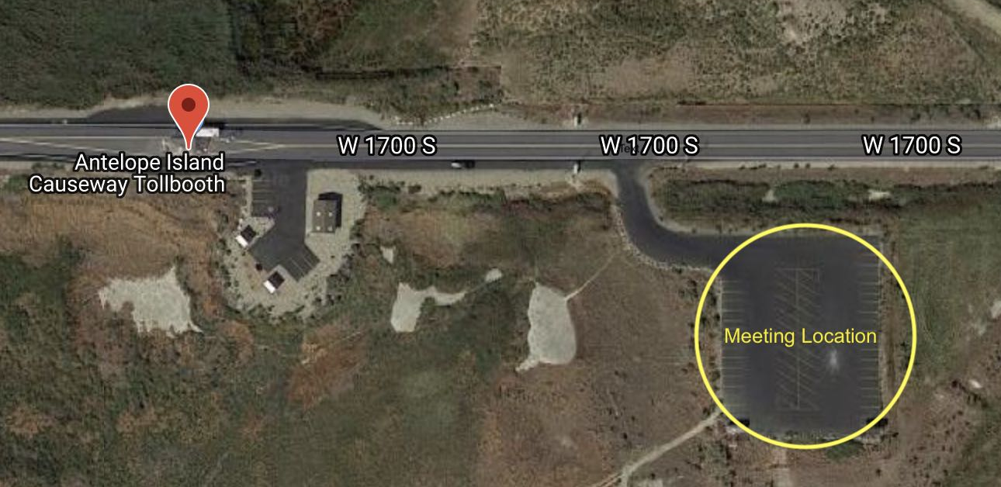

TRANSPORTATION
Schools are responsible for arranging their own transportation to and from the field trip site.
Bus Reimbursement:
FRIENDS of Great Salt Lake provides Bus Reimbursement Grants of up to $300 for public and charter schools. These checks are distributed at the end of our field trip season, and the primary teacher will be responsible for submitting the school’s bus invoice to FRIENDS of Great Salt Lake to receive the grant.
Would your school like to receive up to $300 in reimbursement for field trip bus costs?

ADDITIONAL INFORMATION
Is there anything else you would like us to know about your field trip needs?

REQUIREMENTS AND RESPONSIBILITIES
The following items are the responsibility of the participating school and teachers.
Planning for the field trip:
- Submit a completed, signed application form to FRIENDS of Great Salt Lake.
- Work with FRIENDS to coordinate scheduling details.
- Make necessary bus transportation arrangements.
- Acquire parent/guardian permission documentation.
- Provide a total of 6-15 chaperones for the trip, and request that they carpool or ride the bus. Please ask chaperones in advance to limit side conversations and any other disruptive behavior while we're facilitating. We greatly appreciate it when chaperones can help reinforce our instructions, keep students quiet and engaged, and participate in activities.
Day of the field trip:
- Ensure that students are prepared for weather conditions with proper clothing. We will be outside the entire time getting very dirty, salty, and wet.
  - Students need to bring:
    - Sandals or water shoes for wading into the lake
    - A towel
    - Drinking water
    - A hat
    - A warm layer/rain jacket for cool weather
    - Lunch
  - The lake can be buggy in spring; we recommend students wear long sleeves and long pants.
- Split students into three groups for the field trip program.
- Text or call Katie Newburn at (530) 368-7768 when the bus is leaving the school on the morning of the field trip. We need a final headcount of students, teachers and chaperones to pay the park entrance fee. We also need you to confirm your estimated time of arrival.
- Notify FRIENDS immediately if you are running late (or early) and will not be at Antelope Island at the agreed-upon arrival time.
- Assume responsibility for your students’ behavior and for their treatment of FRIENDS’ equipment. If FRIENDS’ equipment is deliberately broken or is stolen by a member of your group, your school will be responsible for replacement costs.
Cancellation and Rescheduling:
- FRIENDS cannot guarantee that schools will be able to reschedule a field trip due to poor weather or any other circumstances. We will monitor the weather closely leading up to your trip and may need to cancel if conditions are unsafe.
- Schools that cancel with less than 15 days’ notice will be charged a $25 cancelation fee. There is no fee if the cancelation is weather-related.
Your signature below indicates your agreement to the requirements and responsibilities listed above.
Primary Teacher Contact Signature
Date
Please return your completed application to Katie Newburn at pelican@fogsl.org. Thank you!

